DIU ROBOTICS SOCIETY

Beginner for robotics



Al Noman Robin

D-91

**Day 1: Introduction to Robotics & Basic Electronics**

**• What is Robotics? Ove Discussion.,** Applications

### ****What is Robotics?****

Robotics is an interdisciplinary field of engineering and science that deals with the design, construction, operation, and application of robots. Robots are programmable machines, It combines mechanical engineering, electrical engineering, computer science, and artificial intelligence to create machines that can perform tasks autonomously or semi-autonomously. Robots are designed to interact with the physical world, either through human control or using sensors and programmed instructions.

Key components of robotics include:

1. **Mechanical Engineering**: Involves the physical construction of robots, including their structure, joints, and actuators that allow movement.
2. **Electrical Engineering**: Deals with the circuitry and sensors that enable robots to interact with their environment.
3. **Computer Science**: Focuses on the software and algorithms that control the robot's behavior, including artificial intelligence (AI) and machine learning for decision-making and problem-solving.
4. **Control Systems**: The methods and algorithms used to manage the robot's movements and actions.
5. **Sensors and Perception**: Devices and techniques that allow robots to perceive their environment, such as cameras, microphones, and other sensors.
6. **Human-Robot Interaction**: The study of how humans and robots can work together effectively, including the design of user interfaces and communication methods.

### ****Overview & Discussion****

Robotics has evolved significantly over the years, from simple automated machines to highly intelligent systems capable of learning and decision-making. The primary goal of robotics is to improve efficiency, reduce human effort, and perform tasks that may be too dangerous, tedious, or impossible for humans.

**Definition**:

* + A **robot** is a programmable machine capable of carrying out complex tasks automatically or with minimal human intervention.
  + Robotics involves the study of how robots perceive, reason, and act in their environment.

#### **Key Components of Robotics:**

1. **Mechanical Structure** – Provides physical support and mobility (e.g., arms, wheels, legs).
2. **Sensors** – Detect environmental conditions like temperature, motion, distance, and pressure.
3. **Actuators** – Convert electrical signals into movement (e.g., motors, hydraulics).
4. **Control System** – Processes inputs from sensors and decides robot actions.
5. **Software & AI** – Enables robots to learn, adapt, and perform complex tasks.

### ****Applications of Robotics****

Robots are widely used in various industries and fields. Some of the key applications include:

1. **Manufacturing & Automation:**
   * Industrial robots assemble products in factories, increasing speed and precision.
   * Automated welding, painting, and packaging systems.
2. **Healthcare & Medicine:**
   * Surgical robots assist in precise medical procedures (e.g., Da Vinci Surgical System).
   * Rehabilitation robots help in physical therapy and prosthetics.
3. **Agriculture:**
   * Autonomous tractors and drones optimize farming processes.
   * AI-powered robots assist in planting, watering, and harvesting crops.
4. **Military & Defense:**
   * Drones for surveillance, reconnaissance, and combat operations.
   * Robotic bomb disposal units ensure safety in dangerous environments.
5. **Space Exploration:**
   * Rovers like NASA’s Perseverance explore Mars.
   * Robotic arms and satellites aid in space missions.
6. **Service Industry:**
   * AI-powered chatbots and robots assist in customer service.
   * Hotel and restaurant robots serve food and interact with guests.
7. **Household & Personal Use:**
   * Smart home devices like robotic vacuum cleaners (e.g., Roomba).
   * Personal assistant robots like Amazon Alexa and Google Assistant.
8. **Disaster Response & Rescue:**
   * Search and rescue robots help locate survivors in disaster-hit areas.
   * Firefighting robots reduce risks for human firefighters.

**Types of Robots**:

* + **Industrial Robots**: Used in manufacturing (e.g., assembly lines, welding, painting).
  + **Service Robots**: Assist humans in daily tasks (e.g., cleaning robots, delivery robots).
  + **Medical Robots**: Perform surgeries or assist in rehabilitation (e.g., robotic prosthetics, surgical robots like the Da Vinci system).
  + **Exploration Robots**: Operate in extreme or inaccessible environments (e.g., space rovers, underwater drones).
  + **Autonomous Vehicles**: Self-driving cars, drones, and other vehicles that navigate without human input.
  + **Humanoid Robots**: Designed to resemble and mimic human behavior (e.g., Sophia, ASIMO).

**Key Technologies**:

* + **Machine Learning and AI**: Enable robots to learn from data and improve performance.
  + **Computer Vision**: Allows robots to interpret visual information.
  + **Natural Language Processing (NLP)**: Facilitates human-robot communication.
  + **Internet of Things (IoT)**: Connects robots to other devices for coordinated tasks.

**Challenges in Robotics**

1. **Technical Challenges**:
   * Developing advanced AI for decision-making in unpredictable environments.
   * Improving energy efficiency and battery life.
   * Ensuring robust and reliable hardware.
2. **Ethical and Social Challenges**:
   * Addressing job displacement due to automation.
   * Ensuring safety and privacy in human-robot interactions.
   * Ethical concerns around autonomous weapons and AI decision-making.
3. **Cost and Accessibility**:
   * High development and maintenance costs for advanced robots.
   * Making robotics technology accessible to smaller businesses and developing countries.

**Future of Robotics**

The future of robotics is driven by advancements in AI, machine learning, and materials science. Key trends include:

* **Collaborative Robots (Cobots)**: Robots designed to work safely alongside humans.
* **Soft Robotics**: Robots made from flexible materials for delicate tasks.
* **Swarm Robotics**: Coordination of multiple robots to perform tasks collectively.
* **AI-Driven Autonomy**: Robots becoming more adaptive and capable of learning from their environment.
* **Human-Robot Interaction**: Improved communication and collaboration between humans and robots.

• Basic Electrical Components: Resistors, Capacitors, Diodes, Transistors

### ****Resistors****

A **resistor** is a passive electrical component that opposes the flow of electric current in a circuit. It is used to control voltage and current levels, divide voltages, and protect components from excessive current

.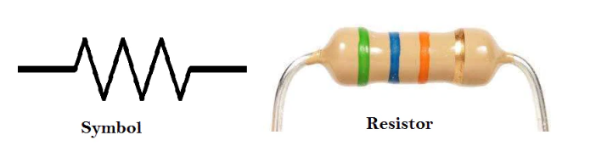

### ****Key Features of Resistors****

* **Symbol:** R
* **Unit:** Ohm (Ω)
* **Formula (Ohm’s Law):**

V=IR

where:

* + V = Voltage (Volts)
  + I = Current (Amperes)
  + R = Resistance (Ohms)

### ****Types of Resistors****

1. **Fixed Resistors** – Have a constant resistance value.
   * **Examples:** Carbon film, Metal film, Wire-wound resistors.
2. **Variable Resistors (Potentiometers, Rheostats, Trimmers)** – Used for adjustable resistance.
3. **Special Resistors:**
   * **Thermistors** – Resistance changes with temperature.
   * **LDR (Light Dependent Resistor)** – Resistance changes with light intensity.

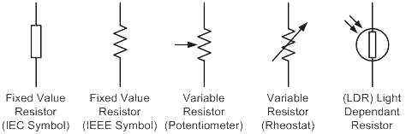

### ****Uses of Resistors****

* Limiting current in circuits (e.g., protecting LEDs)
* Voltage division in circuits (Voltage divider)
* Filtering signals in electronic circuits
* Heat dissipation (Power resistors)

### ****Capacitors****

A **capacitor** is a passive electrical component that **stores and releases electrical energy** in the form of an electric field. It consists of two conductive plates separated by an insulating material called a **dielectric**.

### ****Key Features of Capacitors****

* **Symbol:** C
* **Unit:** **Farad (F)**
* **Basic Formula:** **Q=CV**
  + Q = Charge (Coulombs)
  + C = Capacitance (Farads)
  + V = Voltage (Volts)

### ****How a Capacitor Works****

* When a **voltage** is applied, it **stores charge** on its plates.
* When the voltage source is removed, the capacitor **releases the stored energy**.

### ****Types of Capacitors****

1. **Electrolytic Capacitors** – High capacitance, used in power supply filtering.
2. **Ceramic Capacitors** – Small, used in high-frequency applications.
3. **Tantalum Capacitors** – Stable, used in circuits requiring precise capacitance.
4. **Film Capacitors** – Used in AC circuits and filtering applications.
5. **Supercapacitors** – Extremely high capacitance, used for energy storage.

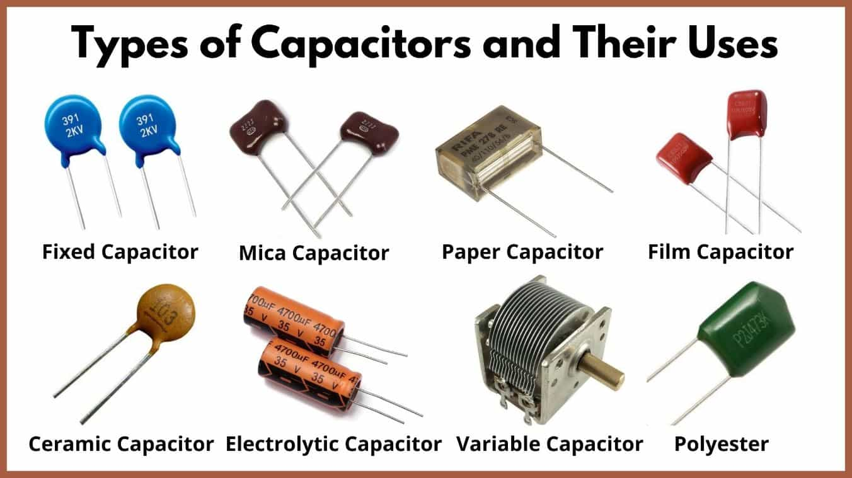

### ****Applications of Capacitors****

* **Energy Storage** – Temporary power backup
* **Filtering** – Removing noise from power supplies
* **Coupling and Decoupling** – Blocking DC and allowing AC signals
* **Timing Circuits** – Used in oscillators and clocks

• Understanding Voltage, Current, and Resistance (Ohm’s Law)

**Understanding Voltage, Current, and Resistance (Ohm’s Law)**

Ohm’s Law is a fundamental principle in electrical engineering that explains the relationship between **Voltage (V)**, **Current (I)**, and **Resistance (R)** in an electrical circuit.

**1. Voltage (V) – The Electrical Pressure**

* **Definition:** Voltage is the potential difference between two points in a circuit that causes electric current to flow.
* **Unit:** **Volt (V)**
* **Symbol:** V
* **Analogy:** Think of voltage like water pressure in a pipe—it pushes the water (current) through the pipe (circuit).

**2. Current (I) – The Flow of Electric Charge**

* **Definition:** Current is the flow of electric charge (electrons) through a conductor.
* **Unit:** **Ampere (A)**
* **Symbol:** I
* **Analogy:** Current is like the flow of water in a pipe.

**3. Resistance (R) – The Opposition to Current Flow**

* **Definition:** Resistance is the opposition to the flow of electric current in a circuit.
* **Unit:** **Ohm (Ω)**
* **Symbol:** R
* **Analogy:** Resistance is like a narrow pipe restricting water flow. The higher the resistance, the less current flows.

**Ohm’s Law: The Relationship Between V, I, and R**

V=IR

Where:

* V = Voltage (Volts)
* I = Current (Amperes)
* R = Resistance (Ohms)

Using this formula, you can calculate:

1. **Voltage:** V=IR
2. **Current:** I=V/R
3. **Resistance:** R=V/I

**Example Calculations**

🔹 **Example 1:** If a circuit has a **resistance** of 10Ω and a **current** of 2A, what is the voltage?

V=2A×10Ω=20V

🔹 **Example 2:** If a 12V battery is connected to a 6Ω resistor, how much current flows?

I=12V/6Ω=2A

**Key Takeaways**

✅ Higher **voltage** = More current flows.  
✅ Higher **resistance** = Less current flows.–  
✅ If **resistance is zero**, current can be **very high** (short circuit).

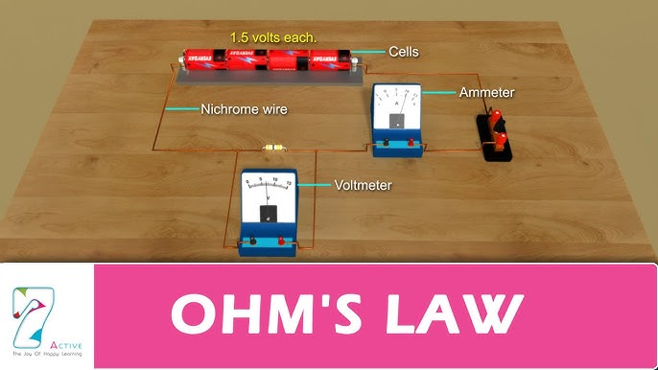

• Power Supply Basics: Batteries, Voltage Regulators, and Power

Distribution

## **1. Batteries: Portable Power Sources**

### ****What is a Battery?****

A **battery** stores chemical energy and converts it into electrical energy. It has two terminals: **positive (+)** and **negative (-)**.

### ****Types of Batteries****

1. **Primary Batteries (Non-Rechargeable)**
   * Examples: Alkaline (AA, AAA), Lithium Coin Cells
   * Use Case: Remote controls, clocks, sensors
2. **Secondary Batteries (Rechargeable)**
   * Examples: Lithium-ion (Li-ion), Nickel-Cadmium (Ni-Cd), Lead-Acid
   * Use Case: Phones, laptops, cars, UPS systems

### ****Key Battery Parameters****

* **Voltage (V):** Determines the potential difference (e.g., AA = 1.5V, Li-ion = 3.7V).
* **Capacity (mAh or Ah):** Amount of charge stored (higher means longer-lasting).
* **Current (A):** The maximum current the battery can supply.

## **2. Voltage Regulators: Ensuring Stable Voltage**

### ****What is a Voltage Regulator?****

A **voltage regulator** maintains a constant output voltage, regardless of input fluctuations. This prevents damage to sensitive electronic components.

### ****Types of Voltage Regulators****

1. **Linear Regulators (LDO - Low Dropout Regulators)**
   * Example: **LM7805 (5V output), LM317 (adjustable voltage)**
   * Simple, but inefficient as excess power is lost as heat.
2. **Switching Regulators (Efficient Power Conversion)**
   * Example: **Buck Converter (Step-Down), Boost Converter (Step-Up)**
   * More efficient (80-90%), used in power-efficient designs.
3. **Zener Diodes (Basic Voltage Regulation)**
   * Used in simple circuits to maintain voltage levels.

## **3. Power Distribution: Managing Electricity in a System**

### ****Key Components in Power Distribution****

1. **Power Adapters and Transformers** – Convert AC (Alternating Current) from wall outlets into DC (Direct Current) for circuits.
2. **Fuses and Circuit Breakers** – Protect against short circuits and overcurrent conditions.
3. **Bus Bars & Power Rails** – Distribute power efficiently across multiple components.
4. **Power Management ICs (PMICs)** – Used in complex devices like smartphones to manage power distribution efficiently.

### ****Power Distribution in Electronics****

* **USB Power**: 5V, commonly used in chargers.
* **Computer Power Supply**: Provides **+12V, +5V, and +3.3V** for different components.
* **Solar Power Systems**: Use batteries, inverters, and charge controllers to manage power.

### ****Conclusion****

✔ **Batteries** provide portable power.  
✔ **Voltage regulators** ensure stable voltage.  
✔ **Power distribution** efficiently delivers electricity to components.

• Hands-on: LED Blinking with a Resistor

### ****Hands-on: LED Blinking with a Resistor****

This simple experiment demonstrates how to use a resistor to protect an LED while powering it with a battery or power supply.

## **🔹 Components Needed**

1. **LED (Light Emitting Diode)** – 1 piece
2. **Resistor (330Ω or 1kΩ)** – 1 piece
3. **Battery (9V or 5V power source)** – 1 piece
4. **Breadboard** – 1 piece
5. **Jumper Wires** – 2 pieces
6. **Switch (optional, for turning it on/off)**

## **🔹 Circuit Diagram**

(+) Battery --- Resistor ---> |--- (-) Battery

(LED)

* The **longer leg** of the LED (anode) connects to the **positive (+) terminal** through the resistor.
* The **shorter leg** (cathode) connects to the **negative (-) terminal** of the battery.

## **🔹 Step-by-Step Instructions**

### ****Step 1: Identify LED Terminals****

* **Anode (+)**: Longer leg
* **Cathode (-)**: Shorter leg

### ****Step 2: Connect the Resistor****

* Attach one end of the **330Ω or 1kΩ resistor** to the **positive (+) terminal** of the battery or power supply.

### ****Step 3: Connect the LED****

* Connect the **resistor's free end** to the **longer leg (anode) of the LED**.
* Connect the **shorter leg (cathode) of the LED** to the **negative (-) terminal** of the battery.

### ****Step 4: Power the Circuit****

* Once the circuit is complete, the LED should turn on.

### ****Step 5: Make the LED Blink (Optional)****

To make the LED blink, you can manually turn it on/off using a **switch** or use a **microcontroller (like Arduino)** with a programmed delay.

## **🔹 Why Use a Resistor?**

The resistor **limits the current** flowing through the LED, preventing it from **burning out**. Without a resistor, too much current would flow, damaging the LED.

Using **Ohm’s Law**, we can calculate the resistor value:

R=V/I

For a **5V supply** and a typical LED current of **20mA (0.02A)**:

R =(5V−2V) / (0.02A) = 150Ω

(Where 2V is the LED forward voltage).

Since 150Ω is a minimum safe value, a **330Ω or 1kΩ resistor** is commonly used.

## **🔹 Next Steps**

* Try using **different resistor values** to see how brightness changes.
* Use an **Arduino or 555 Timer IC** to automate blinking.

**Day 2: Basic C Programming for Robotics**

## 📘 **Introduction to C: Variables, Data Types, and Operators**

### 🧠 What is C?

C is a **high-level programming language** used to write software that can run **fast and close to hardware**. It’s used in:

* Embedded systems (like Arduino, microcontrollers)
* Operating systems (Linux, Windows core)
* Game engines, databases, etc.

## 1️⃣ **Variables in C**

### 🔤 What are Variables?

Variables are **named containers** used to **store data**.

### 📝 Syntax:

data_type variable_name = value;

### 🔍 Example:

int age = 20;

float temperature = 36.5;

char grade = 'A';

## 2️⃣ **Data Types in C**

| **Data Type** | **Description** | **Example** | **Memory** |
| --- | --- | --- | --- |
| int | Integer numbers | 1, -10, 25 | 2/4 B |
| float | Decimal numbers (single) | 3.14, 2.5 | 4 B |
| double | Decimal numbers (double prec.) | 3.141592 | 8 B |
| char | Single character | 'A', 'z' | 1 B |
| void | No value (used in functions) | — | — |

## 3️⃣ **Operators in C**

### ➕ Arithmetic Operators:

| **Operator** | **Meaning** | **Example** |
| --- | --- | --- |
| + | Addition | a + b |
| - | Subtraction | a - b |
| * | Multiplication | a * b |
| / | Division | a / b |
| % | Modulus (remainder) | a % b |

### 🧮 Relational (Comparison) Operators:

| **Operator** | **Meaning** | **Example** |
| --- | --- | --- |
| == | Equal to | a == b |
| != | Not equal to | a != b |
| > | Greater than | a > b |
| < | Less than | a < b |
| >= | Greater than or equal to | a >= b |
| <= | Less than or equal to | a <= b |

### 🔗 Logical Operators:

| **Operator** | **Meaning** | **Example** |
| --- | --- | --- |
| && | AND | (a > 0 && b < 5) |
| ` |  | ` |
| ! | NOT | !(a == b) |

### ✍️ Sample C Program:

#include <stdio.h>

int main() {

int a = 10, b = 5;

int sum = a + b;

float avg = sum / 2.0;

printf("Sum: %d\n", sum);

printf("Average: %.2f\n", avg);

return 0;}

## 🎯 Summary:

* **Variables** store data.
* **Data types** define the type of data (int, float, char, etc.).
* **Operators** perform calculations or comparisons.

## **🔁 Control Structures in C: If-Else, (For, While) Loops**

## 🔷 1. **If-Else Statements**

### 💡 Used when you want to ****make decisions**** in your program.

### 📝 Syntax:

if (condition) {

// Code to run if condition is true

} else {

// Code to run if condition is false

}

### Example:

int temp = 30;

if (temp > 25) {

printf("It's hot outside.\n");

} else {

printf("Nice weather!\n");

}

## 🔄 2. **For Loop**

### 💡 Used when you know ****how many times**** you want to repeat something.

### 📝 Syntax:

for (initialization; condition; update) {

// Code to repeat

}

### Example:

for (int i = 1; i <= 5; i++) {

printf("Number: %d\n", i);

}

🔁 Output:

Number: 1

Number: 2

Number: 3

Number: 4

Number: 5

## 🔁 3. **While Loop**

### 💡 Used when you ****don’t know how many times**** to loop in advance — just keep looping until the condition is false.

### 📝 Syntax:

while (condition) {

// Code to repeat

}

### Example:

int i = 1;

while (i <= 3) {

printf("Hello %d\n", i);

i++;

}

## 🔃 4. **Do-While Loop**

### 💡 Like while, but it runs the block ****at least once****, even if the condition is false.

### 📝 Syntax:

do {

// Code to repeat

} while (condition);

### Example:

int i = 1;

do {

printf("Hi %d\n", i);

i++;

} while (i <= 3);

## 🧠 Example: Using if + for with Arduino-style logic

int light = 300;

if (light > 500) {

printf("Bright light!\n");

} else {

printf("It's dim.\n");

}

for (int i = 0; i < 3; i++) {

printf("Blink LED %d\n", i+1);

}

## 🚦 Summary Table:

| **Structure** | **Use Case** |
| --- | --- |
| if-else | Decision making |
| for | Loop with known repetitions |
| while | Loop with unknown repetitions |
| do-while | Like while, but runs once |

**• Functions and Modular Programming**

Great choice! Let’s dive into **Functions and Modular Programming in C** — this is where your code starts becoming clean, reusable, and scalable. 🔧✨

## 🧩 **What Are Functions in C?**

Functions are **blocks of code** designed to **perform a specific task**. They help make your program:

* **Modular** (organized in smaller pieces)
* **Reusable**
* **Easier to read and debug**

## 🧱 **Function Structure in C**

### 🔹 ****Syntax:****

return_type function_name(parameter_list) {

// code block

return value;

}

### 🔹 ****Example:****

int add(int a, int b) {

return a + b;

}

## 🛠️ **Using Functions in Your Program**

### 🔹 Complete Example:

#include <stdio.h>

// Function declaration

int add(int, int);

int main() {

int result = add(5, 3);

printf("Sum = %d\n", result);

return 0;

}

// Function definition

int add(int x, int y) {

return x + y;

}

## 📦 **Modular Programming**

Modular programming means **breaking the program into smaller files/modules**, each handling a specific part.

### 🔹 Benefits:

* Easier to debug
* Reusable code
* Makes large projects manageable

### 🧩 Typical C Project Structure:

main.c --> main program logic

math_utils.c --> helper functions

math_utils.h --> header file with declarations

### 🧾 Example:

**math_utils.h**:

// Function declarations

int add(int a, int b);

int subtract(int a, int b);

**math_utils.c**:

#include "math_utils.h"

int add(int a, int b) {

return a + b;

}

int subtract(int a, int b) {

return a - b;

}

**main.c**:

#include <stdio.h>

#include "math_utils.h"

int main() {

int x = 10, y = 4;

printf("Add: %d\n", add(x, y));

printf("Subtract: %d\n", subtract(x, y));

return 0;

}

Compile with:

gcc main.c math_utils.c -o program

## 🔃 Types of Functions

| **Type** | **Example** |
| --- | --- |
| With return & parameters | int add(int, int) |
| With return, no param | int getNumber() |
| No return, with param | void printSum(int, int) |
| No return, no param | void greet() |

## ✅ Summary:

* **Functions** organize your logic.
* **Modular programming** splits big projects into multiple manageable files.
* Use **.h files** to declare functions, and **.c files** to define them.
* Helps in **code reuse, testing, and collaboration**.

**• Arrays and Pointers (Basic Understanding)**

## 🧮 **1. Arrays in C (Basics)**

### 🔹 What is an Array?

An **array** is a **collection of variables** (all of the same type), stored in **contiguous memory** locations.

### 📝 Syntax:

data_type array_name[size];

### Example:

int numbers[5] = {10, 20, 30, 40, 50};

### 🔁 Accessing Elements:

printf("%d", numbers[2]); // Output: 30

### 🔁 Looping through an array:

for(int i = 0; i < 5; i++) {

printf("%d ", numbers[i]);

}

## 📍 **2. Pointers in C (Basics)**

### 🔹 What is a Pointer?

A **pointer** is a variable that **stores the memory address** of another variable.

### 📝 Syntax:

data_type *pointer_name;

### Example:

int x = 10;

int *ptr = &x; // ptr stores the address of x

printf("Value of x: %d\n", x); // 10

printf("Address of x: %p\n", &x); // e.g., 0x7ffee...

printf("Value at ptr: %d\n", *ptr); // 10

## 📌 Pointer & Array Connection

* Array names **act like pointers**.
* numbers[i] is the same as *(numbers + i)

### 🔍 Example:

int arr[3] = {5, 10, 15};

int *p = arr;

printf("%d\n", *(p + 1)); // Output: 10

## 🧠 Why Arrays + Pointers Matter:

| **Feature** | **Arrays** | **Pointers** |
| --- | --- | --- |
| Fixed size? | Yes | No (flexible via malloc) |
| Fast access? | Yes | Yes |
| Used with? | Loops, strings, data | Memory, functions, arrays |
| In embedded C? | Sensor buffers, memory | UART, ADC, memory access |

## 🧪 Mini Example:

#include <stdio.h>

int main() {

int data[3] = {100, 200, 300};

int *ptr = data;

for(int i = 0; i < 3; i++) {

printf("data[%d] = %d (via pointer: %d)\n", i, data[i], *(ptr + i));

}

return 0;

}

## 🔐 Summary:

| **Concept** | **Key Idea** |
| --- | --- |
| Array | Stores multiple values in one name |
| Pointer | Holds the address of a variable |
| * | Dereference operator (get value) |
| & | Address-of operator |
| arr[i] | Same as *(arr + i) |

**• Hands-on: Writing a C Program for a Simple Task**

### C Program: Sum of Two Numbers

#include <stdio.h>

int main() {

// Declare variables

int num1, num2, sum;

// Ask for user input

printf("Enter the first number: ");

scanf("%d", &num1);

printf("Enter the second number: ");

scanf("%d", &num2);

// Calculate the sum

sum = num1 + num2;

// Display the result

printf("The sum of %d and %d is: %d\n", num1, num2, sum);

return 0;

}

### Explanation:

1. **Header File**: #include <stdio.h> - Includes the Standard Input-Output library needed for printf and scanf functions.
2. **Variables**: We declare three variables (num1, num2, and sum) to store the two numbers input by the user and their sum.
3. **User Input**: scanf is used to read the input values for num1 and num2 from the user.
4. **Calculation**: We calculate the sum of num1 and num2 and store it in the sum variable.
5. **Output**: printf prints the result in a formatted manner, showing the input numbers and their sum.
6. **Return Statement**: The return 0; indicates successful execution.

### Sample Output:

Enter the first number: 5

Enter the second number: 3

The sum of 5 and 3 is: 8

**Day 3: Introduction to Arduino and Programming Basics**

**• What is Arduino? Overview of the Arduino Board**

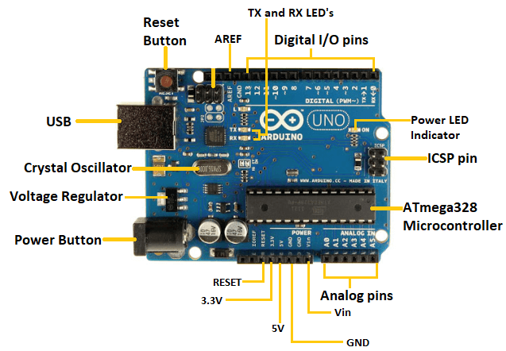

### What is Arduino?

**Arduino** is an open-source electronics platform based on simple software and hardware. It's designed to make it easier for people (especially beginners) to create interactive electronic projects. It consists of both a **microcontroller board** and a **software development environment**.

Arduino is widely used in hobbyist projects, prototyping, education, and even in more advanced systems. It allows you to interact with the real world by reading sensors, controlling motors, lights, and much more.

### ****Overview of the Arduino Board****

The Arduino board is essentially a small, programmable microcontroller that allows you to control electronic components like LEDs, motors, and sensors. It’s a **physical board** with inputs and outputs, which is connected to your computer to upload programs (called **sketches**) written in the Arduino IDE (Integrated Development Environment).

### Key Components of an Arduino Board:

1. **Microcontroller**:
   * The heart of the Arduino board. It processes the code and controls input/output. For example, in the **Arduino Uno**, the microcontroller is the **ATmega328P**.
2. **Digital I/O Pins**:
   * The Arduino has pins that can be configured as either input or output. These pins can be used to read digital signals (like a button press) or send digital signals (like turning on an LED).
   * **Digital Pins (0-13)** are used for digital signals (HIGH/LOW).
3. **Analog Pins**:
   * These pins are used for reading continuous signals (e.g., from sensors that provide varying voltage).
   * **Analog Pins (A0-A5)** are typically used to read voltages and convert them to a digital value using the board’s ADC (Analog-to-Digital Converter).
4. **Power Pins**:
   * These are used to supply the board with power or to provide power to external devices.
     + **Vin**: Used to power the board from an external source (7-12V).
     + **5V**: Supplies 5V output (regulated).
     + **3.3V**: Supplies 3.3V output (used for certain low-voltage devices).
     + **GND**: Ground pins.
5. **USB Port**:
   * Used to connect the Arduino board to your computer for power and communication. You can upload code to the board via the USB connection.
6. **Reset Button**:
   * When pressed, it resets the Arduino board, causing it to start over from the beginning of the uploaded program.
7. **Serial Communication Pins** (TX/RX):
   * Used for communication between the Arduino and external devices (e.g., for debugging or connecting sensors or modules).
8. **LED (Pin 13)**:
   * Many Arduino boards come with a built-in LED connected to digital pin 13. It's useful for testing and debugging.

### ****Popular Arduino Boards:****

1. **Arduino Uno**:
   * The most popular and commonly used Arduino board, based on the ATmega328P microcontroller.
   * Great for beginners, offers 14 digital pins, 6 analog pins, and works well with various shields and sensors.
2. **Arduino Nano**:
   * A smaller version of the Uno, designed to fit on a breadboard. It’s great for projects where space is limited.
3. **Arduino Mega**:
   * A more powerful version of the Arduino board with more I/O pins (54 digital pins, 16 analog pins) and more memory, suited for larger and more complex projects.
4. **Arduino Leonardo**:
   * Uses the ATmega32u4 microcontroller, allowing it to act as a USB device like a mouse or keyboard.
5. **Arduino Due**:
   * Based on a 32-bit ARM Cortex-M3 processor, it offers more processing power than the 8-bit boards like the Uno.

### ****Arduino IDE (Integrated Development Environment)****

The **Arduino IDE** is the software you use to write and upload code to your Arduino board. It’s user-friendly and uses a language based on C/C++, so you can write simple programs (called **sketches**) that can control your Arduino board. It includes:

* **Editor** for writing code.
* **Compiler** to convert code into machine-readable form.
* **Uploader** to send the compiled code to the Arduino board via USB.

### ****Why Arduino?****

1. **Easy to Use**:
   * Arduino has a simple development environment, making it easy for beginners to learn electronics and programming.
2. **Open Source**:
   * Both the hardware (Arduino board) and software (Arduino IDE) are open-source, meaning anyone can modify and share their designs.
3. **Wide Range of Applications**:
   * Arduino is used in a wide variety of projects, including robotics, home automation, IoT devices, sensor-based systems, and much more.
4. **Extensive Community**:
   * Arduino has a massive online community with plenty of tutorials, resources, and projects. Whether you're a beginner or an advanced user, you'll find support and inspiration.

### ****Applications of Arduino:****

* **Home Automation**: Use sensors to control lights, temperature, or other devices.
* **Robotics**: Control motors and sensors to create robots.
* **Wearable Technology**: Build wearable devices like health monitors or smartwatches.
* **IoT Projects**: Create devices that communicate over the internet, like smart thermostats or weather stations.
* **Educational Projects**: Ideal for teaching electronics and programming to beginners.

**• Installing the Arduino IDE and Writing First Code**

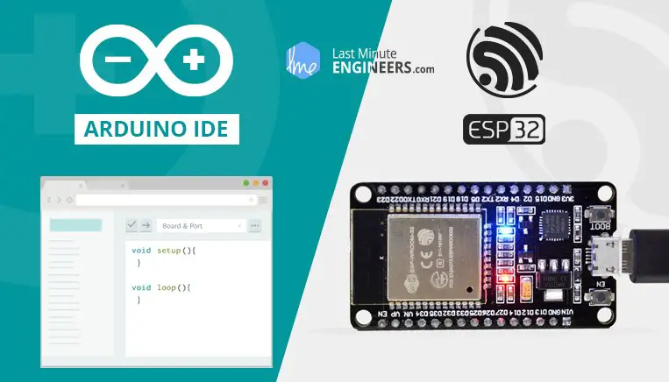

### Installing the Arduino IDE and Writing Your First Code

To get started with Arduino programming, you'll need to **install the Arduino IDE** (Integrated Development Environment), which is the software you use to write and upload code to the Arduino board. Once installed, you'll be ready to write your first program!

### ****Step 1: Install the Arduino IDE****

#### For **Windows**:

1. Go to the official [Arduino website](https://www.arduino.cc/en/software) to download the IDE for your operating system.
2. Under **Windows**, click the "Windows" option.
3. Once the installer is downloaded, **run the .exe file** to start the installation process.
4. Follow the instructions to complete the installation.
   * **Select "Install drivers"** if prompted to install necessary drivers for the Arduino board.
5. After the installation finishes, open the Arduino IDE from your Start menu.

#### For **macOS**:

1. Go to the official [Arduino website](https://www.arduino.cc/en/software) and download the **macOS** version.
2. Open the downloaded .dmg file and **drag the Arduino application** into the Applications folder.
3. Once installed, you can launch the Arduino IDE from the **Applications** folder.

#### For **Linux**:

1. Download the **Linux version** of the Arduino IDE from the official [Arduino website](https://www.arduino.cc/en/software).
2. Extract the tar file and follow the instructions in the **README** file for installation.

### ****Step 2: Connect Your Arduino Board****

1. **Connect your Arduino** board to your computer using a **USB cable**.
2. Make sure your board is powered up (an LED should light up).
3. **Select your board type** in the Arduino IDE:
   * Go to **Tools > Board** and select your specific Arduino board (e.g., Arduino Uno).
4. **Select the correct port** where your Arduino is connected:
   * Go to **Tools > Port** and select the port that corresponds to your Arduino board.

### ****Step 3: Writing Your First Arduino Code****

Now that everything is set up, you can write your first code to test the board.

Here’s the famous **Blink LED** example, where the built-in LED on your Arduino board will blink on and off every second.

#### **Blinking LED Code:**

void setup() {

pinMode(LED_BUILTIN, OUTPUT); // Initialize the LED pin as an output

}

void loop() {

digitalWrite(LED_BUILTIN, HIGH); // Turn the LED on

delay(1000); // Wait for 1 second (1000 milliseconds)

digitalWrite(LED_BUILTIN, LOW); // Turn the LED off

delay(1000); // Wait for 1 second

}

### ****Code Breakdown****:

* **setup()**: This function runs once when the board is powered on or reset. Here, you initialize the built-in LED pin (pin 13 on most Arduino boards) as an **output** using pinMode().
* **loop()**: After the setup(), the **loop()** function runs repeatedly. Inside this function, you control the LED by turning it on (digitalWrite(LED_BUILTIN, HIGH)) and off (digitalWrite(LED_BUILTIN, LOW)), with a **delay** of 1 second in between each action.

### ****Step 4: Uploading Code to the Arduino****

Once you have written your first code, it's time to **upload it to your Arduino board**:

1. Click the **Upload** button (the right arrow icon) in the Arduino IDE.
2. The IDE will compile your code and upload it to the Arduino.
3. Once uploaded, the built-in LED on your Arduino board should start blinking on and off every second.

### ****Step 5: Verifying the Output****

After uploading the code:

* **Check the LED**: The built-in LED (usually on pin 13) should blink **on and off** at 1-second intervals.
* If the LED doesn't blink, double-check your board type, port, and ensure the code was uploaded without any errors.

### ****Step 6: Troubleshooting Common Issues****

* **Board not recognized**: Make sure you've installed the necessary drivers for your Arduino board. On Windows, the drivers should install automatically when you install the IDE.
* **Upload failed**: Ensure that the correct board and port are selected in the **Tools** menu. You can try restarting the IDE or reconnecting the board.
* **No response from the LED**: Check your physical Arduino connections, and ensure that you're using the built-in LED on your specific board (most Arduino boards have one on pin 13).

### ****Step 7: Next Steps****

Now that you’ve successfully written your first Arduino code, you can start experimenting with other basic projects and gradually move on to more complex tasks.

* **Experiment with other LEDs**: Try connecting external LEDs to different pins and control them via the code.
* **Explore different sensors**: Start experimenting with sensors like temperature sensors, photoresistors, or motion sensors.
* **Write more complex programs**: Try combining inputs and outputs, like controlling an LED with a button.

### ****Resources for Learning Arduino****

* **Official Arduino Website**: [https://www.arduino.cc](https://www.arduino.cc/)
* **Arduino Project Hub**: <https://create.arduino.cc/projecthub>
* **Instructables Arduino Projects**: [https://www.instructables.com](https://www.instructables.com/)

**• Basic Arduino Syntax: Digital Read/Write, Analog Read**

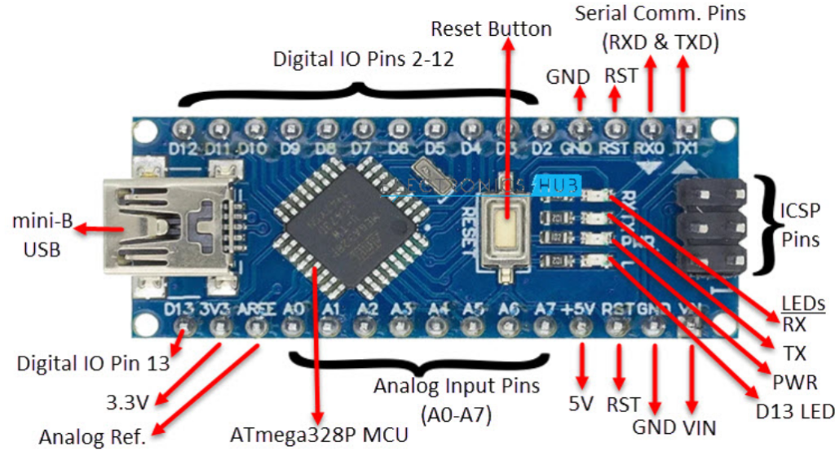

### ****1. Digital Read and Write****

In Arduino, digital pins are used to read or write **binary** values (either **HIGH** or **LOW**). This is essential for controlling devices like **LEDs**, **buttons**, and **relays**.

#### **Digital Write:**

The **digitalWrite()** function is used to send a digital signal (HIGH or LOW) to a digital pin.

**Syntax:**

digitalWrite(pin, value);

* **pin**: The pin number (e.g., 13 for the built-in LED).
* **value**: Either HIGH (5V) or LOW (0V).

#### **Example: Turning an LED On/Off:**

void setup() {

pinMode(13, OUTPUT); // Set pin 13 as an output (built-in LED)

}

void loop() {

digitalWrite(13, HIGH); // Turn the LED on

delay(1000); // Wait for 1 second

digitalWrite(13, LOW); // Turn the LED off

delay(1000); // Wait for 1 second

}

* **pinMode(13, OUTPUT)**: This sets pin 13 (built-in LED on most Arduino boards) as an output pin.
* **digitalWrite(13, HIGH)**: Turns the LED on (5V).
* **digitalWrite(13, LOW)**: Turns the LED off (0V).
* **delay(1000)**: Pauses the program for 1 second (1000 milliseconds).

#### **Digital Read:**

The **digitalRead()** function is used to read the state (HIGH or LOW) of a digital input pin. This is typically used with **buttons** or **sensors**.

**Syntax:**

int state = digitalRead(pin);

* **pin**: The pin number to read from.
* **state**: A variable that stores the result, which will be either HIGH (if the pin is HIGH) or LOW (if the pin is LOW).

#### **Example: Reading a Button Press:**

int buttonPin = 7; // Pin connected to the button

int buttonState = 0; // Variable to store the button state

void setup() {

pinMode(buttonPin, INPUT); // Set buttonPin as an input

Serial.begin(9600); // Start serial communication

}

void loop() {

buttonState = digitalRead(buttonPin); // Read the button state

if (buttonState == HIGH) {

Serial.println("Button is pressed!");

} else {

Serial.println("Button is not pressed!");

}

delay(500); // Wait for half a second

}

* **pinMode(buttonPin, INPUT)**: Sets pin 7 as an input pin to read the button.
* **digitalRead(buttonPin)**: Reads the state of the button (HIGH if pressed, LOW if not).
* **Serial.println()**: Outputs the result to the Serial Monitor.

### ****2. Analog Read and Write****

Arduino also supports reading **analog signals**. These signals are continuous (unlike digital signals) and range from 0 to 1023 when read by the **analogRead()** function, which corresponds to 0V to 5V (on most boards).

#### **Analog Read:**

The **analogRead()** function reads the voltage on an analog pin (0 to 5V). The returned value is an integer between **0** and **1023**.

**Syntax:**

int sensorValue = analogRead(pin);

* **pin**: The analog pin number (e.g., A0 for analog pin 0).
* **sensorValue**: A variable to store the value, ranging from 0 to 1023.

#### **Example: Reading a Potentiometer Value:**

int potPin = A0; // Pin connected to the potentiometer

int potValue = 0; // Variable to store potentiometer value

void setup() {

Serial.begin(9600); // Start serial communication

}

void loop() {

potValue = analogRead(potPin); // Read the potentiometer value

Serial.println(potValue); // Print the value to the Serial Monitor

delay(500); // Wait for half a second

}

* **analogRead(A0)**: Reads the value of the potentiometer connected to pin A0.
* **Serial.println(potValue)**: Displays the potentiometer value (ranging from 0 to 1023) on the Serial Monitor.

#### **Analog Write (PWM)**:

To control the brightness of an LED or the speed of a motor, you can use **Pulse Width Modulation (PWM)** with the **analogWrite()** function. This simulates an analog output by rapidly switching the pin HIGH and LOW at varying duty cycles.

**Syntax:**

analogWrite(pin, value);

* **pin**: The pin number that supports PWM (typically pins 3, 5, 6, 9, 10, and 11 on most boards).
* **value**: A value between **0** and **255**, where 0 means OFF and 255 means fully ON.

#### **Example: Fading an LED (PWM)**:

int ledPin = 9; // Pin connected to the LED

int brightness = 0; // Variable to store brightness level

void setup() {

pinMode(ledPin, OUTPUT); // Set the LED pin as an output

}

void loop() {

// Fade the LED from 0 to 255

for (brightness = 0; brightness <= 255; brightness++) {

analogWrite(ledPin, brightness); // Set the LED brightness

delay(10); // Wait for 10 milliseconds to create a smooth fade

}

// Fade the LED from 255 to 0

for (brightness = 255; brightness >= 0; brightness--) {

analogWrite(ledPin, brightness); // Set the LED brightness

delay(10); // Wait for 10 milliseconds to create a smooth fade

}

}

* **analogWrite(ledPin, brightness)**: Controls the brightness of the LED on pin 9 using PWM.
* **brightness**: The brightness level ranges from 0 (off) to 255 (fully on).

### ****Summary of Functions:****

| **Function** | **Description** | **Syntax** |
| --- | --- | --- |
| digitalWrite() | Set a digital pin HIGH or LOW | digitalWrite(pin, value) |
| digitalRead() | Read the state (HIGH/LOW) of a digital pin | digitalRead(pin) |
| analogRead() | Read an analog pin value (0-1023) | analogRead(pin) |
| analogWrite() | Write an analog value (PWM, 0-255) | analogWrite(pin, value) |

**• Serial Communication with Arduino**

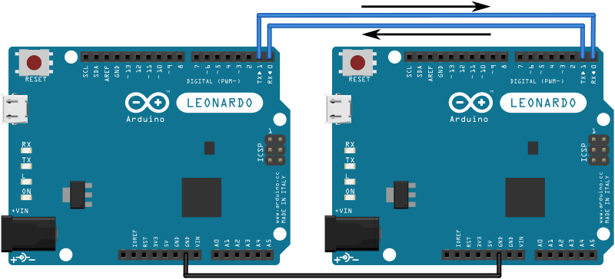

### ****Serial Communication with Arduino****

**Serial Communication** is a method used to send and receive data between the Arduino board and a computer or other devices using the **serial port**. It's essential for debugging, controlling external devices, and interfacing with other microcontrollers or sensors.

### ****What is Serial Communication?****

* **Serial Communication** means data is transferred one bit at a time over a communication channel.
* In Arduino, the **Serial Monitor** allows you to send and receive data between the Arduino and your computer.
* It can be used to **debug** your code, **view sensor data**, or even **send commands** to your Arduino board.

### ****1. Serial.begin() - Start Serial Communication****

The first step in serial communication is to initialize the **serial port** using the Serial.begin() function. This function starts the communication at a specified baud rate (the speed at which data is transmitted).

#### **Syntax:**

Serial.begin(baud_rate);

* **baud_rate**: The rate at which data is transmitted, typically **9600**, **115200**, or others (depending on the application and hardware).

#### **Example: Initializing Serial Communication:**

void setup() {

Serial.begin(9600); // Start serial communication at 9600 baud rate

}

void loop() {

// Your main code here

}

This will initialize communication on your Arduino board, allowing it to exchange data via the USB port (which acts as a serial connection).

### ****2. Serial.print() - Sending Data****

The Serial.print() function is used to send data to the **Serial Monitor** (or to a serial device). You can send numbers, characters, or strings.

#### **Syntax:**

Serial.print(data);

* **data**: The value or text you want to send (can be a variable, a constant, or a string).

#### **Example: Sending Text and Data:**

void setup() {

Serial.begin(9600); // Start serial communication at 9600 baud rate

}

void loop() {

int temperature = 25; // Example variable

Serial.print("Temperature: "); // Print the label

Serial.println(temperature); // Print the temperature value and move to the next line

delay(1000); // Wait for 1 second

}

* **Serial.print("Temperature: ")**: Prints the string to the Serial Monitor.
* **Serial.println(temperature)**: Prints the value of temperature and moves to the next line.

### ****3. Serial.println() - Sending Data with a New Line****

The Serial.println() function is similar to Serial.print(), but it **adds a new line** after the output, making it easier to format your data when displayed.

#### **Example: Sending Data with a New Line:**

void setup() {

Serial.begin(9600); // Start serial communication

}

void loop() {

Serial.println("Arduino is sending data!"); // Prints the string and moves to a new line

delay(1000); // Wait for 1 second

}

This will print the message to the Serial Monitor every second and move to a new line.

### ****4. Serial.read() - Receiving Data****

You can also **receive data** sent from the Serial Monitor or another serial device using the Serial.read() function. This function reads one byte of data at a time from the serial buffer.

#### **Syntax:**

byte data = Serial.read();

* **data**: The received byte (it will be stored as a byte or char).

#### **Example: Reading Data from Serial Monitor:**

void setup() {

Serial.begin(9600); // Start serial communication

}

void loop() {

if (Serial.available() > 0) { // Check if data is available

char receivedChar = Serial.read(); // Read one byte of data

Serial.print("Received: ");

Serial.println(receivedChar); // Print the received character

}

}

* **Serial.available()**: Checks if there is any data available in the serial buffer.
* **Serial.read()**: Reads one byte of incoming data.

### ****5. Serial.parseInt() - Reading Numeric Data****

You can read **integer values** from the Serial Monitor using Serial.parseInt(). This function automatically handles numeric input and converts the received data into an integer.

#### **Syntax:**

int value = Serial.parseInt();

* **value**: The integer value read from the serial buffer.

#### **Example: Reading Integer Values:**

void setup() {

Serial.begin(9600); // Start serial communication

}

void loop() {

if (Serial.available() > 0) { // Check if data is available

int number = Serial.parseInt(); // Read an integer from Serial Monitor

Serial.print("Received Number: ");

Serial.println(number); // Print the received number

}

}

* **Serial.parseInt()**: Reads and returns the integer value sent from the Serial Monitor.

### ****6. Example: Simple Serial Communication Program****

Here’s a simple example where the Arduino reads a number from the Serial Monitor and turns an LED on or off based on the input:

#### **Code Example: Control LED using Serial Monitor**

int ledPin = 13; // Pin connected to the LED

void setup() {

pinMode(ledPin, OUTPUT); // Set LED pin as output

Serial.begin(9600); // Start serial communication

}

void loop() {

if (Serial.available() > 0) { // If data is available

int command = Serial.parseInt(); // Read the integer command

if (command == 1) {

digitalWrite(ledPin, HIGH); // Turn LED ON

Serial.println("LED is ON");

} else if (command == 0) {

digitalWrite(ledPin, LOW); // Turn LED OFF

Serial.println("LED is OFF");

}

}

}

* **Serial.parseInt()** reads a number from the Serial Monitor.
* If the number is 1, the LED turns on; if it's 0, the LED turns off.

### ****7. Key Serial Functions Recap:****

| **Function** | **Description** |
| --- | --- |
| Serial.begin() | Initializes serial communication at a specified baud rate. |
| Serial.print() | Sends data to the Serial Monitor without a newline. |
| Serial.println() | Sends data to the Serial Monitor with a newline. |
| Serial.read() | Reads one byte of data from the serial buffer. |
| Serial.parseInt() | Reads and parses integer data from the serial buffer. |
| Serial.available() | Checks if data is available to read. |

### ****8. Conclusion****

Serial communication is a powerful tool for **debugging**, **interacting** with your Arduino, and **exchanging data** with your computer or other devices. The **Serial Monitor** in the Arduino IDE is a great place to test and develop communication with your Arduino board.

By using Serial.print(), Serial.println(), and Serial.read(), you can build interactive projects that communicate with the outside world and display real-time data.

**• Hands-on: Blinking LED using**

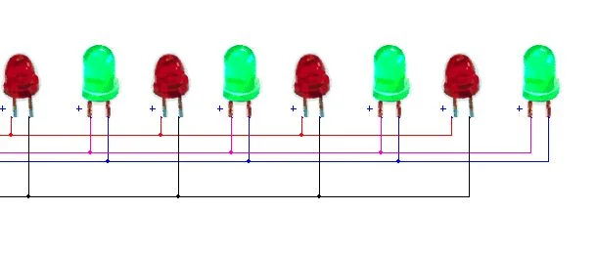

### ****Components Needed:****

* Arduino board (e.g., Arduino Uno)
* **LED** (Light Emitting Diode)
* **220-ohm resistor**
* Jumper wires
* Breadboard (optional)

### ****Circuit Diagram:****

1. **LED:**
   * The longer leg (anode) of the LED goes to **pin 13** on the Arduino.
   * The shorter leg (cathode) of the LED goes to **GND** (Ground) through a **220-ohm resistor**.

### ****Step-by-Step Instructions:****

#### **Step 1: Setup Circuit**

1. Insert the LED into the breadboard (if using one).
2. Connect the **anode** (longer leg) of the LED to **pin 13** on the Arduino.
3. Connect the **cathode** (shorter leg) of the LED to the **GND** pin on the Arduino through a **220-ohm resistor**.

#### **Step 2: Write the Code**

Here’s the code to blink the LED:

void setup() {

pinMode(13, OUTPUT); // Set pin 13 as an output pin for the LED

}

void loop() {

digitalWrite(13, HIGH); // Turn the LED on (HIGH)

delay(1000); // Wait for 1 second (1000 milliseconds)

digitalWrite(13, LOW); // Turn the LED off (LOW)

delay(1000); // Wait for 1 second (1000 milliseconds)

}

### ****Code Explanation:****

1. **pinMode(13, OUTPUT)**: In the setup() function, we set pin 13 (the pin connected to the LED) as an output. This means that we will control the LED by sending either HIGH (on) or LOW (off) signals to this pin.
2. **digitalWrite(13, HIGH)**: This turns the LED on by sending a HIGH (5V) signal to pin 13.
3. **delay(1000)**: This pauses the program for 1 second (1000 milliseconds), keeping the LED on.
4. **digitalWrite(13, LOW)**: This turns the LED off by sending a LOW (0V) signal to pin 13.
5. **delay(1000)**: This again pauses the program for 1 second, keeping the LED off.
6. **loop()**: The loop() function runs repeatedly, making the LED blink on and off continuously.

#### **Step 3: Upload the Code**

1. Open the **Arduino IDE** on your computer.
2. Select the correct **board type** (e.g., Arduino Uno) under **Tools > Board**.
3. Select the correct **port** under **Tools > Port**.
4. Click the **Upload** button (right arrow icon) in the IDE to upload the code to your Arduino.

### ****Step 4: Observe the LED Blinking****

Once the code is uploaded, the LED connected to pin 13 should start blinking on and off every second.

* **On** for 1 second
* **Off** for 1 second
* This loop will continue indefinitely.

### ****Troubleshooting Tips:****

1. **LED Not Blinking?**
   * Ensure that the LED is connected correctly (anode to pin 13 and cathode to GND via the resistor).
   * Double-check the code for any typos.
   * Verify that the Arduino is connected to your computer and that the correct port and board are selected in the IDE.
2. **LED Stays On or Off Continuously?**
   * If the LED stays on or off constantly, it might be due to an issue with the wiring or incorrect pin configuration.
   * Ensure the pinMode(13, OUTPUT) line is in the setup() function.

**Day 4-5 :** **Sensors and Their Applications in Robotics**

• What are Sensors? Types of Sensors in Robotics

A **sensor** is a device that detects and measures physical changes in the environment, such as light, temperature, pressure, motion, or sound, and converts them into signals that can be processed by a system, such as a robot or a computer. They play a crucial role in automation, IoT (Internet of Things), robotics, and everyday electronics.

**Purpose of Sensors**

Sensors are used in various applications to:

* **Gather data** from the environment.
* **Enable automation** in machines and robots.
* **Enhance accuracy** in measurement and control systems.
* **Improve safety** by detecting hazards (e.g., fire, gas leaks).

**How Sensors Work**

1. The sensor **detects** a physical property (e.g., temperature, pressure).
2. They detect changes (e.g., temperature, light, motion).
3. It **converts** the detected property into an electrical signal.
4. The signal is **processed** by a system (robot, microcontroller, or computer).
5. The system takes **action** based on the sensor data.
6. Send data to a microcontroller (e.g., Arduino, Raspberry Pi) or computer for processing.

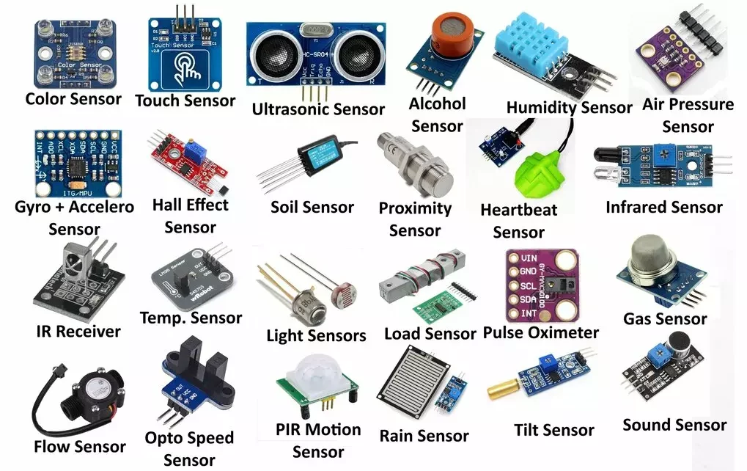

**Types of Sensors:**

### 🌡️ ****1. Temperature Sensors****

* **Examples**: Thermocouples, Thermistors, RTDs
* **Use**: Measure heat or temperature.
* **Applications**: HVAC systems, weather monitoring, medical thermometers.

### 📏 ****2. Proximity Sensors****

* **Examples**: Infrared (IR), Ultrasonic, Capacitive, Inductive
* **Use**: Detect the presence or absence of an object without physical contact.
* **Applications**: Parking sensors, smartphones (screen off near ear), robotics.

### 💡 ****3. Light Sensors****

* **Examples**: Photodiodes, LDR (Light Dependent Resistor)
* **Use**: Measure light intensity.
* **Applications**: Automatic lighting, smartphones (auto-brightness), solar trackers.

### 📶 ****4. Pressure Sensors****

* **Examples**: Strain gauge, Piezoelectric sensors
* **Use**: Measure the force applied over an area.
* **Applications**: Weather stations (barometers), car tire pressure monitoring, industrial systems.

### 🔊 ****5. Sound Sensors****

* **Examples**: Microphones, Piezoelectric sensors
* **Use**: Detect sound waves.
* **Applications**: Voice recognition systems, hearing aids, surveillance.

### 🧭 ****6. Motion Sensors****

* **Examples**: Accelerometers, Gyroscopes, PIR (Passive Infrared)
* **Use**: Detect movement or orientation.
* **Applications**: Smartphones (screen rotate), gaming (controllers), security systems.

### 💧 ****7. Humidity Sensors****

* **Examples**: Hygrometers, Capacitive humidity sensors
* **Use**: Measure moisture in the air.
* **Applications**: Weather forecasting, HVAC systems, greenhouses.

### ⚡ ****8. Gas and Chemical Sensors****

* **Examples**: MQ series (e.g., MQ-2, MQ-135), Electrochemical sensors
* **Use**: Detect specific gases or chemical substances.
* **Applications**: Air quality monitors, industrial safety, breath analyzers.

### 🧲 ****9. Magnetic Sensors****

* **Examples**: Hall Effect sensors, Magnetometers
* **Use**: Detect magnetic fields.
* **Applications**: Compass apps, automotive systems, position tracking.

### 📡 ****10. Image Sensors****

* **Examples**: CMOS, CCD
* **Use**: Capture images and videos.
* **Applications**: Cameras, smartphones, security systems.

### 🌐 ****11. Touch Sensors****

* **Examples**: Capacitive, Resistive touch sensors
* **Use**: Detect physical contact or pressure on a surface.
* **Applications**: Smartphones, touchscreens, kiosks, ATMs.

### 🚦 ****12. Color Sensors****

* **Examples**: TCS34725, RGB sensors
* **Use**: Detect and distinguish between different colors.
* **Applications**: Industrial automation, printers, food sorting.

### 📶 ****13. Infrared (IR) Sensors****

* **Use**: Emit and/or detect infrared radiation.
* **Applications**: Remote controls, obstacle detection, night vision.

### 💦 ****14. Water/Fluid Level Sensors****

* **Examples**: Ultrasonic, Float switch, Capacitive sensors
* **Use**: Detect the level of liquid in a container.
* **Applications**: Water tanks, fuel monitoring, industrial processes.

### 🧪 ****15. pH Sensors****

* **Use**: Measure the acidity or alkalinity of a solution.
* **Applications**: Water treatment, agriculture, chemical labs.

### 🧬 ****16. Biosensors****

* **Use**: Detect biological elements (like glucose, DNA, bacteria).
* **Applications**: Medical diagnostics, blood glucose monitoring, environmental monitoring.

### 🌎 ****17. GPS (Global Positioning System) Sensors****

* **Use**: Determine location using satellite signals.
* **Applications**: Navigation, tracking systems, mapping apps.

### ⚙️ ****18. Force Sensors****

* **Examples**: Load cells, piezo sensors
* **Use**: Measure applied force or load.
* **Applications**: Weighing scales, robotics, industrial automation.

### 🔋 ****19. Current and Voltage Sensors****

* **Examples**: ACS712, Hall effect-based sensors
* **Use**: Measure electric current or voltage in circuits.
* **Applications**: Energy meters, battery management systems.

### 🌪️ ****20. Vibration Sensors****

* **Examples**: Accelerometers, Piezoelectric sensors
* **Use**: Detect mechanical vibrations.
* **Applications**: Machinery health monitoring, earthquake detection.

### 🕹️ ****21. Tilt Sensors****

* **Use**: Detect the orientation or tilting angle of an object.
* **Applications**: Mobile devices, game controllers, vehicle safety.

### 🌬️ ****22. Airflow Sensors****

* **Use**: Measure the speed of air movement.
* **Applications**: HVAC systems, engine management, clean rooms.

### 🧱 ****23. Displacement Sensors****

* **Examples**: LVDT (Linear Variable Differential Transformer)
* **Use**: Measure linear or angular displacement.
* **Applications**: Robotics, automation, structural monitoring.

### 🔍 ****24. Optical Sensors****

* **Use**: Convert light rays into electronic signals.
* **Examples**: Fiber optic sensors, phototransistors
* **Applications**: Object detection, communication systems, safety curtains in industries.

### 🧊 ****25. Frost/Ice Sensors****

* **Use**: Detect frost or ice buildup.
* **Applications**: Refrigerators, aircraft systems, road safety systems.

### 🧲 ****26. Eddy Current Sensors****

* **Use**: Detect displacement, position, or cracks in metal via magnetic fields.
* **Applications**: Non-destructive testing, vibration monitoring, machine maintenance.

### 🔬 ****27. Ultrasonic Sensors****

* **Use**: Use ultrasonic waves to measure distance.
* **Applications**: Obstacle detection, liquid level sensing, blind assistance.

### 🧼 ****28. Capacitive Soil Moisture Sensors****

* **Use**: Measure the volumetric water content in soil.
* **Applications**: Precision agriculture, irrigation systems.

### 🛣️ ****29. Road Surface Condition Sensors****

* **Use**: Detect slipperiness, moisture, or temperature on road surfaces.
* **Applications**: Smart roads, weather forecasting, traffic management.

### 💎 ****30. Strain Gauges****

* **Use**: Measure strain (deformation) in materials.
* **Applications**: Structural health monitoring, load measurement.

### 🧠 ****31. EEG Sensors (Electroencephalogram)****

* **Use**: Measure electrical activity in the brain.
* **Applications**: Neuroscience, brain-computer interfaces, medical diagnostics.

### ❤️ ****32. ECG Sensors (Electrocardiogram)****

* **Use**: Detect electrical signals of the heart.
* **Applications**: Heart monitoring, wearable health devices.

### 👁️ ****33. Eye Tracking Sensors****

* **Use**: Track the position and movement of the eyes.
* **Applications**: Human-computer interaction, gaming, research studies.

### 📈 ****34. Radar Sensors****

* **Use**: Use radio waves to detect range, angle, or velocity of objects.
* **Applications**: Automotive (collision avoidance), defense, weather monitoring.

### 🛰️ ****35. LIDAR Sensors (Light Detection and Ranging)****

* **Use**: Measure distances using laser light.
* **Applications**: Autonomous vehicles, 3D mapping, archaeology.

### 🏥 ****36. Pulse Oximeters****

* **Use**: Measure oxygen saturation in the blood.
* **Applications**: Healthcare, fitness trackers.

### 🌪️ ****37. Barometric Pressure Sensors****

* **Use**: Measure atmospheric pressure.
* **Applications**: Altitude detection, weather stations, drones.

### 🦾 ****38. Tactile Sensors****

* **Use**: Detect touch, force, or pressure distribution.
* **Applications**: Robotics, prosthetics, touchscreens.

### 🧯 ****39. Flame/Fire Sensors****

* **Use**: Detect the presence of flame via infrared or UV spectrum.
* **Applications**: Fire alarms, industrial safety.

### 🧭 ****40. Inclinometers****

* **Use**: Measure angles of slope (tilt) or elevation.
* **Applications**: Construction, geotechnical monitoring, mobile devices.

### 💨 ****41. Smoke Sensors****

* **Use**: Detect smoke particles in the air.
* **Examples**: Ionization, Photoelectric
* **Applications**: Fire detection, safety systems.

### 📻 ****42. Antenna Sensors****

* **Use**: Sense signal strength or direction for wireless communication.
* **Applications**: IoT devices, mobile towers, radar systems.

### 🌐 ****43. RFID Sensors (Radio-Frequency Identification)****

* **Use**: Read data stored in RFID tags via radio waves.
* **Applications**: Inventory tracking, smart cards, toll collection.

### 🛢️ ****44. Leak Detection Sensors****

* **Use**: Detect fluid or gas leaks.
* **Applications**: Pipelines, industrial tanks, home safety systems.

**🌱 45. Chlorophyll/NDVI Sensors**

* **Use**: Measure plant health by detecting light reflection.
* **Applications**: Agriculture, environmental monitoring, remote sensing.

• Overview of Common Sensors: IR Sensor, Ultrasonic Sensor, Temperature Sensor, Humidity Senor, LDR Sensor, Fire Sensor, PirMotion Sensor, MQ2 Sensor, Soil measurements sensor etc.

**Detailed Overview of Common Sensors & Arduino Interfacing**

**1. Infrared (IR) Sensor**

**Overview**

* IR sensors detect obstacles or measure object distance using infrared light.
* They have an **IR LED (emitter)** and a **photodiode (receiver)**.
* Common models: **IR module (TCRT5000, FC-51)**

**Connection with Arduino**

| **IR Sensor Pin** | **Arduino Pin** |
| --- | --- |
| VCC | 5V |
| GND | GND |
| OUT | Digital Pin (e.g., D2) |

**Code Example**

int IR_Pin = 2;

void setup() {

pinMode(IR_Pin, INPUT);

Serial.begin(9600);

}

void loop() {

int value = digitalRead(IR_Pin);

Serial.println(value ? "No Obstacle" : "Obstacle Detected");

delay(500);

}

**2. Ultrasonic Sensor (HC-SR04)**

**Overview**

* Measures distance using ultrasonic waves.
* Sends out a sound pulse and measures the time it takes to bounce back.

**Connection with Arduino**

| **HC-SR04 Pin** | **Arduino Pin** |
| --- | --- |
| VCC | 5V |
| GND | GND |
| Trig | Digital Pin (e.g., D9) |
| Echo | Digital Pin (e.g., D10) |

**Code Example**

#define trigPin 9

#define echoPin 10

void setup() {

Serial.begin(9600);

pinMode(trigPin, OUTPUT);

pinMode(echoPin, INPUT);

}

void loop() {

digitalWrite(trigPin, LOW);

delayMicroseconds(2);

digitalWrite(trigPin, HIGH);

delayMicroseconds(10);

digitalWrite(trigPin, LOW);

long duration = pulseIn(echoPin, HIGH);

int distance = duration * 0.034 / 2;

Serial.print("Distance: ");

Serial.print(distance);

Serial.println(" cm");

delay(500);

}

**3. Temperature Sensor (LM35)**

**Overview**

* Measures temperature and gives an analog output.
* Voltage increases by **10mV per degree Celsius**.

**Connection with Arduino**

| **LM35 Pin** | **Arduino Pin** |
| --- | --- |
| VCC | 5V |
| GND | GND |
| OUT | A0 |

**Code Example**

int tempPin = A0;

void setup() {

Serial.begin(9600);

}

void loop() {

int value = analogRead(tempPin);

float voltage = value * (5.0 / 1023.0);

float temperature = voltage * 100;

Serial.print("Temperature: ");

Serial.print(temperature);

Serial.println(" °C");

delay(1000);

}

**4. Humidity and Temperature Sensor (DHT11)**

**Overview**

* Measures **temperature** and **humidity**.
* Uses **1 digital pin** to send data.

**Connection with Arduino**

| **DHT11 Pin** | **Arduino Pin** |
| --- | --- |
| VCC | 5V |
| GND | GND |
| Data | Digital Pin (e.g., D2) |

**Code Example**

#include <DHT.h>

#define DHTPIN 2

#define DHTTYPE DHT11

DHT dht(DHTPIN, DHTTYPE);

void setup() {

Serial.begin(9600);

dht.begin();

}

void loop() {

float h = dht.readHumidity();

float t = dht.readTemperature();

Serial.print("Humidity: ");

Serial.print(h);

Serial.print(" %\tTemperature: ");

Serial.print(t);

Serial.println(" °C");

delay(2000);

}

💡 **Install the DHT library in Arduino IDE: Sketch > Include Library > Manage Libraries > Search “DHT” and Install.**

**5. Light Dependent Resistor (LDR)**

**Overview**

* Changes resistance based on light intensity.
* Gives an **analog output**.

**Connection with Arduino**

| **LDR Pin** | **Arduino Pin** |
| --- | --- |
| VCC | 5V |
| GND | GND |
| Output | A0 |

**Code Example**

int LDR_Pin = A0;

void setup() {

Serial.begin(9600);

}

void loop() {

int lightValue = analogRead(LDR_Pin);

Serial.print("Light Intensity: ");

Serial.println(lightValue);

delay(500);

}

**6. Fire Sensor (Flame Sensor)**

**Overview**

* Detects flames using infrared light.
* Outputs **HIGH (1)** if no fire and **LOW (0)** if fire is detected.

**Connection with Arduino**

| **Fire Sensor Pin** | **Arduino Pin** |
| --- | --- |
| VCC | 5V |
| GND | GND |
| OUT | D2 |

**Code Example**

int FireSensor = 2;

void setup() {

pinMode(FireSensor, INPUT);

Serial.begin(9600);

}

void loop() {

int status = digitalRead(FireSensor);

if (status == LOW) {

Serial.println("🔥 Fire Detected!");

} else {

Serial.println("No Fire");

}

delay(500);

}

**7. PIR Motion Sensor**

**Overview**

* Detects movement of humans or animals.
* Outputs **HIGH (1) when motion is detected**.

**Connection with Arduino**

| **PIR Pin** | **Arduino Pin** |
| --- | --- |
| VCC | 5V |
| GND | GND |
| OUT | D2 |

**Code Example**

int PIR = 2;

void setup() {

pinMode(PIR, INPUT);

Serial.begin(9600);

}

void loop() {

int motion = digitalRead(PIR);

if (motion == HIGH) {

Serial.println("Motion Detected! 🚶‍♂️");

}

delay(500);

}

**8. Gas Sensor (MQ2)**

**Overview**

* Detects **LPG, methane, smoke**.
* Outputs **analog value**.

**Connection with Arduino**

| **MQ2 Pin** | **Arduino Pin** |
| --- | --- |
| VCC | 5V |
| GND | GND |
| AOUT | A0 |

**Code Example**

int MQ2 = A0;

void setup() {

Serial.begin(9600);

}

void loop() {

int gasValue = analogRead(MQ2);

Serial.print("Gas Level: ");

Serial.println(gasValue);

delay(500);

}

**9. Soil Moisture Sensor**

**Overview**

* Measures **soil moisture levels**.
* Analog output indicates soil dryness.

**Connection with Arduino**

| **Soil Sensor Pin** | **Arduino Pin** |
| --- | --- |
| VCC | 5V |
| GND | GND |
| AOUT | A0 |

**Code Example**

int SoilSensor = A0;

void setup() {

Serial.begin(9600);

}

void loop() {

int moisture = analogRead(SoilSensor);

Serial.print("Soil Moisture: ");

Serial.println(moisture);

delay(500);

}

• Connecting and Interfacing Sensors with Arduino

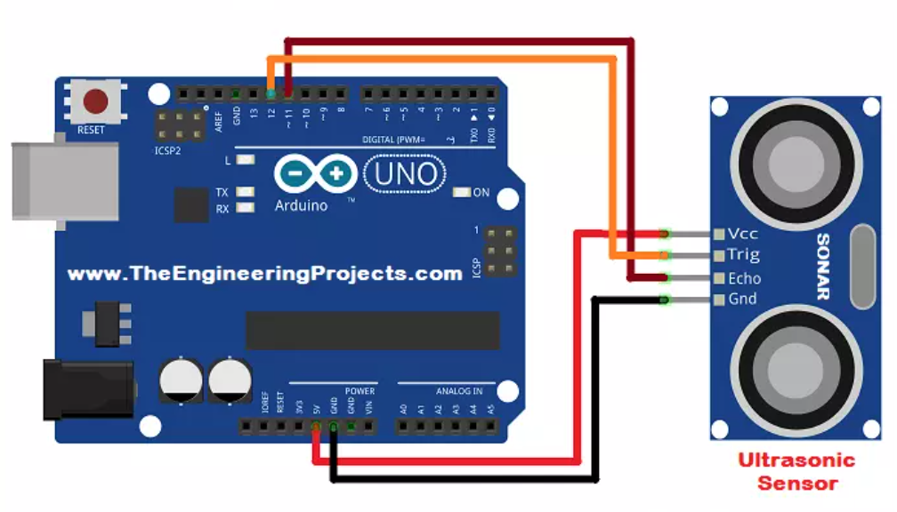

## 🧠 SENSOR INTERFACING BASICS

### 🧩 Arduino Pin Categories:

| **Type** | **Pins** | **Use** |
| --- | --- | --- |
| **Analog** | A0–A5 | For analog sensors (0–1023) |
| **Digital** | D0–D13 | For HIGH/LOW input/output |
| **PWM** | D3, D5, D6, D9, D10, D11 | For analog output using PWM |
| **Power** | 5V, 3.3V, GND | Power supply for sensors |
| **I2C** | SDA (A4), SCL (A5) | Communication for I2C sensors |
| **SPI** | D10 (CS), D11 (MOSI), D12 (MISO), D13 (SCK) | SPI protocol |

## **🔧 1. Analog Sensor Interfacing**

**Example**: **LDR (Light Dependent Resistor)**

### 🧪 ****Components Needed:****

* LDR
* 10kΩ resistor
* Arduino UNO
* Jumper wires

### 🔌 ****Wiring Diagram:****

* One side of LDR → 5V
* Other side of LDR → A0
* Between LDR & GND → 10kΩ resistor (voltage divider)

### 🧠 ****Concept****: Light changes resistance of LDR → changes voltage at A0

### 🧾 ****Arduino Code:****

int ldrPin = A0;

void setup() {

Serial.begin(9600);

}

void loop() {

int lightVal = analogRead(ldrPin);

Serial.println(lightVal); // 0 = dark, 1023 = bright

delay(500);

}

## **🔧 2. Digital Sensor Interfacing**

**Example**: **PIR Motion Sensor**

### 🔌 ****Wiring:****

* VCC → 5V
* GND → GND
* OUT → D2

### 🧠 ****Concept****: Detects movement using IR – gives HIGH on detection

### 🧾 ****Arduino Code:****

int pirPin = 2;

void setup() {

pinMode(pirPin, INPUT);

Serial.begin(9600);

}

void loop() {

if (digitalRead(pirPin) == HIGH) {

Serial.println("Motion detected!");

} else {

Serial.println("No motion.");

}

delay(500);

}

## **🔧 3. I2C Sensor Interfacing**

**Example**: **BMP280 (Pressure + Temp Sensor)**

### 🔌 ****Wiring:****

| **BMP280 Pin** | **Arduino UNO Pin** |
| --- | --- |
| VCC | 3.3V |
| GND | GND |
| SDA | A4 |
| SCL | A5 |

### 🧠 ****Concept****: I2C uses address + 2 wires to send data

### 🧾 ****Arduino Code:****

#include <Wire.h>

#include <Adafruit_BMP280.h>

Adafruit_BMP280 bmp;

void setup() {

Serial.begin(9600);

if (!bmp.begin(0x76)) {

Serial.println("BMP280 not found!");

while (1);

}

}

void loop() {

Serial.print("Temp: ");

Serial.print(bmp.readTemperature());

Serial.println(" °C");

Serial.print("Pressure: ");

Serial.print(bmp.readPressure() / 100.0);

Serial.println(" hPa");

delay(2000);

}

## 🔧 4. **Ultrasonic Sensor Interfacing**

**Sensor**: **HC-SR04**

### 🔌 ****Wiring:****

* VCC → 5V
* GND → GND
* TRIG → D9
* ECHO → D10

### 🧠 ****Concept****: Sends ultrasonic pulse, measures time to bounce back

### 🧾 ****Arduino Code:****

#define trigPin 9

#define echoPin 10

void setup() {

Serial.begin(9600);

pinMode(trigPin, OUTPUT);

pinMode(echoPin, INPUT);

}

void loop() {

digitalWrite(trigPin, LOW); delayMicroseconds(2);

digitalWrite(trigPin, HIGH); delayMicroseconds(10);

digitalWrite(trigPin, LOW);

long duration = pulseIn(echoPin, HIGH);

float distance = duration * 0.034 / 2;

Serial.print("Distance: ");

Serial.print(distance);

Serial.println(" cm");

delay(500);

}

## ⚡ TIPS FOR SUCCESSFUL SENSOR INTERFACING

| **Tip** | **Why It Helps** |
| --- | --- |
| 🔋 **Check voltage levels** | Some sensors need **3.3V**, not 5V |
| 📚 **Use libraries** | Makes complex sensors plug-and-play |
| 🪛 **Use resistors** | Especially with analog sensors like LDR |
| 🔄 **Add delays** | Avoid sensor reading spam and noise |
| ⚠️ **Debounce digital inputs** | Reduces false triggering (e.g., from motion sensors) |
| 📊 **Calibrate sensors** | Ensures accurate readings (especially analog and gas sensors) |

• Hands-on: Reading Sensor Data using Serial Monitor.

## 🧪 **Project Title: Reading Analog Sensor Data Using Serial Monitor**

### 🎯 ****Objective:****

Read analog values from a sensor (e.g., **LM35**, **LDR**, or any analog sensor) and display them in the **Serial Monitor**.

## 🧰 **You’ll Need:**

* Arduino Uno (or compatible board)
* Analog sensor (e.g., LM35 or LDR)
* 10kΩ resistor (for LDR)
* Breadboard and jumper wires
* Arduino IDE

## 🔌 **Wiring Example (LDR Sensor):**

5V

|

[ ]

[ ] LDR

|------> A0 (to Arduino analog pin)

|

[10kΩ]

|

GND

🔁 This is a voltage divider circuit. You can replace the LDR with any other analog sensor (e.g., LM35).

## 💻 **Arduino Code:**

int sensorPin = A0; // Analog pin where the sensor is connected

int sensorValue = 0;

void setup() {

Serial.begin(9600); // Initialize serial communication at 9600 baud

}

void loop() {

sensorValue = analogRead(sensorPin); // Read value from analog pin (0-1023)

// Print the value to Serial Monitor

Serial.print("Sensor Value: ");

Serial.println(sensorValue);

delay(500); // Wait for half a second

}

## 📈 **What You’ll See in the Serial Monitor:**

* Numbers ranging from **0 to 1023** based on sensor input
  + LM35: around 150–300 (for 15°C–30°C)
  + LDR: lower values in dark, higher in bright light

📌 **To open Serial Monitor:**  
In Arduino IDE, go to **Tools → Serial Monitor** or press **Ctrl+Shift+M**.

## ⚙️ **Optional Upgrade: Convert to Voltage or Real Values**

float voltage = sensorValue * (5.0 / 1023.0); // Convert to voltage

Serial.print("Voltage: ");

Serial.println(voltage);

## 🧠 Useful Tips:

* Change delay(500) to delay(100) for faster updates.
* If you get garbage data, check if baud rate in Serial Monitor is **9600**.
* You can plot live graphs in the **Serial Plotter** (Tools → Serial Plotter).

**Day 6-7:** **Mini Project – Sensor-based Application**

• Selecting a Sensor-based Simple Project

If you're looking to select a **sensor-based simple project**, here are a few beginner-friendly and practical ideas that use basic sensors and can be done with platforms like Arduino or Raspberry Pi:

**🔧 1. Temperature & Humidity Monitor**

* **Sensors:** DHT11 or DHT22
* **What it does:** Reads temperature and humidity and displays it on an LCD or serial monitor.
* **Use case:** Room climate monitoring.

**💡 2. Automatic Light System**

* **Sensor:** LDR (Light Dependent Resistor)
* **What it does:** Turns lights on/off based on ambient light.
* **Use case:** Smart lighting for energy saving.

**🚶‍♂️ 3. Motion Detector Alarm**

* **Sensor:** PIR (Passive Infrared) Sensor
* **What it does:** Detects movement and triggers a buzzer or LED.
* **Use case:** Simple security system.

**🌊 4. Water Level Indicator**

* **Sensor:** Ultrasonic sensor or water level probes
* **What it does:** Measures the water level in a tank and gives an alert when full/empty.
* **Use case:** Water tank automation.

**🔥 5. Fire or Gas Leak Detector**

* **Sensor:** Flame sensor / MQ-2 Gas Sensor
* **What it does:** Detects fire or gas leakage and activates an alert.
* **Use case:** Safety alarm system.

**🏠 6. Smart Doorbell System**

* **Sensor:** IR Sensor + Push button
* **What it does:** Detects presence at the door, rings a bell or sends notification.
* **Use case:** Home automation.

• Writing and Uploading the Code

Awesome! Let’s go step-by-step. First, choose one of the sensor projects (like the **Temperature & Humidity Monitor with DHT11**) and I’ll walk you through:

## ✅ Let’s pick: **Temperature & Humidity Monitor using DHT11 and Arduino**

### 🔧 ****Components Needed:****

* Arduino Uno
* DHT11 sensor
* 10k resistor (optional)
* Breadboard & jumper wires
* LCD (optional for display) or just use Serial Monitor

### 🧠 ****Arduino Code:****

Make sure you install the **DHT sensor library** before uploading.

#include "DHT.h"

#define DHTPIN 2 // DHT sensor connected to digital pin 2

#define DHTTYPE DHT11 // DHT11 sensor

DHT dht(DHTPIN, DHTTYPE);

void setup() {

Serial.begin(9600);

dht.begin();

}

void loop() {

float humidity = dht.readHumidity();

float temperature = dht.readTemperature(); // Celsius

if (isnan(humidity) || isnan(temperature)) {

Serial.println("Failed to read from DHT sensor!");

return;

}

Serial.print("Temperature: ");

Serial.print(temperature);

Serial.print(" °C | Humidity: ");

Serial.print(humidity);

Serial.println(" %");

delay(2000); // Wait for 2 seconds

}

### 🧰 ****How to Upload the Code:****

1. Open **Arduino IDE**.
2. Go to **Sketch > Include Library > Manage Libraries**.
3. Search for and install DHT sensor library by Adafruit and Adafruit Unified Sensor.
4. Paste the code into the IDE.
5. Select your **board and port** from **Tools > Board** and **Tools > Port**.
6. Click the **Upload** button (right arrow).
7. Open the **Serial Monitor** (Ctrl + Shift + M) to view output.

• Testing and Debugging

### ****Step-by-Step Testing Guide****

#### 1. **Check Hardware Connections**

* DHT11 typically has **3 pins**:
  + **VCC** → 5V on Arduino
  + **GND** → GND
  + **OUT/SIGNAL** → D2 (as per code)
* Double-check that wires are firmly connected and there's no loose contact.

#### 2. **Library Verification**

* Make sure the **DHT library** and **Adafruit Unified Sensor library** are both installed.
* If not, go to **Tools > Manage Libraries** and search for DHT.

#### 3. **Upload and Open Serial Monitor**

* Upload the code to Arduino.
* Open the **Serial Monitor** from the IDE (top right or Ctrl + Shift + M).
* Set baud rate to **9600** (match the code: Serial.begin(9600);).

### 🐞 ****Common Debugging Issues & Fixes****

#### 🔸 Problem: **“Failed to read from DHT sensor!”**

* **Cause:** Sensor not connected properly, or it's not initialized.
* **Fix:**
  + Ensure correct data pin is used (D2 in code).
  + Try adding a **10k pull-up resistor** between VCC and signal pin.
  + Make sure the sensor is not damaged.
  + Wait a few seconds after powering up — DHT11 can be a bit slow to start.

#### 🔸 Problem: **No output in Serial Monitor**

* **Cause:** Serial not working or baud rate mismatch.
* **Fix:**
  + Check if Serial.begin(9600); matches Serial Monitor baud.
  + Recheck port under **Tools > Port**.
  + Try pressing the **Reset** button on Arduino after uploading.

#### 🔸 Problem: **Weird or unstable values**

* **Cause:** Power supply noise or unstable sensor.
* **Fix:**
  + Use a stable 5V power source.
  + Add a small capacitor (100nF) between VCC and GND near the sensor.
  + Increase delay in loop() to 3–5 seconds (delay(3000);).

### ****Bonus Tip: Add Debug Prints****

To trace issues, you can add Serial.println("Step X"); messages to check where the code might be failing.

Example:

void setup() {

Serial.begin(9600);

Serial.println("Starting DHT11 Sensor");

dht.begin();

}

void loop() {

Serial.println("Reading sensor...");

float humidity = dht.readHumidity();

float temperature = dht.readTemperature();

...

}

• Finalizing the Project and Discussion.

Awesome! You’re almost there — let’s **finalize your project** and prepare for **discussion or presentation**. Here’s how to wrap it all up in a clean, complete way:

## ✅ **1. Final Hardware Setup**

* Make sure all **wires are neatly arranged** on a breadboard or PCB.
* Secure the DHT11 sensor with a proper base or glue if needed.
* If you want, add:
  + An **LCD** for visual output.
  + A **case or enclosure** for presentation polish.
* Double-check your wiring before turning on the power.

## ✅ **2. Final Code Touch-Up**

* Remove unnecessary Serial.println() debug lines unless you’re using them for output.
* Comment your code for clarity:
* // Initialize DHT sensor
* DHT dht(DHTPIN, DHTTYPE);
* // Read and print temperature and humidity
* float humidity = dht.readHumidity(); // in %
* float temperature = dht.readTemperature(); // in °C

## ✅ **3. Project Report/Discussion Points**

### ****Project Title:****

**“Temperature & Humidity Monitoring System using DHT11”**

### 🔍 ****Objective:****

To build a simple, low-cost system that monitors room temperature and humidity using the DHT11 sensor and Arduino.

### 🛠️ ****Components Used:****

* Arduino Uno
* DHT11 Sensor
* Breadboard & jumper wires
* Optional: LCD display

### 🔄 ****Working Principle:****

* The DHT11 sensor reads temperature and humidity data.
* Arduino processes the data and displays it via Serial Monitor (or LCD).
* Updates every 2–3 seconds.

### 📊 ****Applications:****

* Smart home climate monitoring
* Agricultural humidity control
* Weather stations
* Server room temp monitoring

### 💬 ****Possible Improvements:****

* Add an LCD or OLED display.
* Send data wirelessly using Wi-Fi (ESP8266).
* Log data to SD card.
* Trigger alerts based on thresholds.

## ✅ **4. Demo Tips**

* Keep it simple and short.
* Start with: “This is a temperature and humidity monitor I built using Arduino.”
* Show the hardware, explain connections briefly.
* Open Serial Monitor and explain the output.
* Mention real-world uses and future scope.

• Final Project Submission

## 🗓️ **Final Submission Checklist**

### ✅ Hardware:

* Sensor circuit is complete and working
* All components secured neatly on breadboard or base
* Tested multiple times for stable readings

### ✅ Code:

* Fully functional and bug-free
* Properly commented for readability
* Optional: Cleaned up from debug lines

### ✅ Report / Documentation:

* **Project Title & Objective**
* **Components Used**
* **Circuit Diagram** (can be drawn in software like Fritzing or by hand)
* **Code snippet** with explanation
* **Working principle**
* **Applications and future improvements**
* Optional: Photos of hardware setup

### ✅ Optional Enhancements (Bonus points):

* LCD/OLED display
* Custom enclosure or box
* Additional feature (like alerts or data logging)

### ✅ Submission Format:

* Written report (PDF or printed)
* Arduino code (.ino file)
* Video or live demo ready, if required

**Simulator Name:**

1. Tinkercad (Free, Beginner-Friendly)

2. Wokwi (Free & Advanced Features)

3. Proteus (Paid, Professional Use)

4. Fritzing (Open-Source, Visual Learning)

5. SimulIDE (Lightweight, Open-Source)

**Few free Sources for Tutorials:**

• https://www.youtube.com/@ALLABOUTELECTRONICS

• https://www.youtube.com/@ElectroBOOM

• https://www.youtube.com/@toptechboy

• https://www.youtube.com/@RoboCircuits

• https://www.youtube.com/@CreativeCreator